Bahria University,

Karachi Campus



COURSE: SEL-334 OBJECT ORIENTED SOFTWARE ENGINEERING

TERM: SPRING 2019, CLASS: BSE- 4 (A)

ASSIGHNMENT

Submitted By:

______HAMMAD SHAIKH_________________51717______________

(Name) (Reg. No.)

Submitted To:

Engr. Wafa Qaiser Khan/ Engr. Misbah Perveen

Signed Remarks: Score:

**TASK : Shopping dll library**

**\*\*\*\*\*\*\* Shopping form \*\*\*\*\*\*\***

using System;

using System.Collections.Generic;

using System.ComponentModel;

using System.Data;

using System.Drawing;

using System.Linq;

using System.Text;

using System.Threading.Tasks;

using System.Windows.Forms;

using ClassLibrary2;

namespace Assignment_1

{

public partial class shop : Form

{

int a = 178, b = 176, c = 200, t = 0;

public shop() { InitializeComponent(); }

private void shopingform_Load(object sender, EventArgs e) { t1.Enabled = false; t2.Enabled = false; t3.Enabled = false; t4.Enabled = false; CID.Text = Form1.a1.counter().ToString(); }

private void checkBox3_CheckedChanged(object sender, EventArgs e) { if (cb4.Checked) { t4.Enabled = true; } else { t4.Enabled = false; } }

private void cb1_CheckedChanged(object sender, EventArgs e)

{

if (cb1.Checked)

{ t1.Enabled = true; }

else { t1.Enabled = false; }

}

private void cb2_CheckedChanged(object sender, EventArgs e)

{

if (cb2.Checked)

{ t2.Enabled = true; }

else { t2.Enabled = false; }

}

private void cb3_CheckedChanged(object sender, EventArgs e)

{

if (cb3.Checked)

{ t3.Enabled = true; }

else { t3.Enabled = false; }

}

private void button1_Click(object sender, EventArgs er)

{

int e = 0, f = 0, g = 0, h = 0;

if (cb1.Checked) { e = Convert.ToInt32(t1.Text.ToString()); }

if (cb2.Checked) { f = Convert.ToInt32(t1.Text.ToString()); }

if (cb3.Checked) { g = Convert.ToInt32(t1.Text.ToString()); }

if (cb4.Checked) { h = Convert.ToInt32(t1.Text.ToString()); }

t = Form1.a1.totalamount(a, b, c, d, e, f, g, h, cb1.Checked, cb2.Checked, cb3.Checked, cb4.Checked); rtb1.Clear();

rtb1.Text = "Product \t\t\tPrice \tQuantity ";

if (cb1.Checked) { rtb1.Text += "\n Ice Cream - \t\t" + a + "\t\t" + t1.Text.ToString(); }

if (cb2.Checked) { rtb1.Text += "\n Game " + b + "\t\t" + t2.Text.ToString(); }

if (cb3.Checked) { rtb1.Text += "\n (French Fries) - " + c + "\t\t" + t3.Text.ToString(); }

rtb1.Text += "\n TOTAL PRICE :\t\t\t" + t;

}

private void button2_Click(object sender, EventArgs e) { Login A = new Login(); A.Show(); this.Hide(); }

private void label1_Click(object sender, EventArgs e)

{

}

}

}

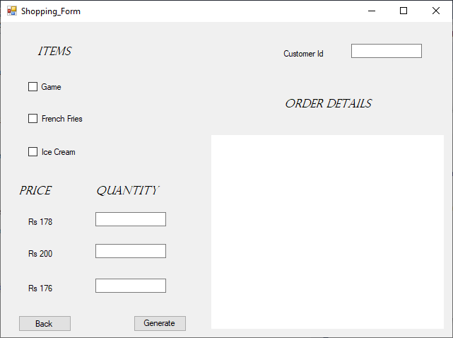

**\*\*\*\*\*\*\*\*\*\*\*\* Select user type form \*\*\*\*\*\*\*\*\*\*\***

using System;

using System.Collections.Generic;

using System.ComponentModel;

using System.Data;

using System.Drawing;

using System.Linq;

using System.Text;

using System.Threading.Tasks;

using System.Windows.Forms;

using ClassLibrary2;

namespace Assignment_1

{

public partial class Form1 : Form

{

public static Class1 a1 = new Class1();

public Form1() { InitializeComponent(); }

private void Form1_Load(object sender, EventArgs e)

{

}

private void button1_Click_1(object sender, EventArgs e)

{ signup A = new signup(); this.Hide(); A.Show(); }

private void button2_Click(object sender, EventArgs e)

{ login a = new login(); this.Hide(); a.Show(); }

}

}

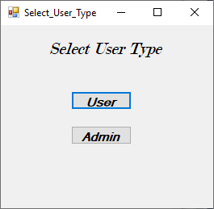

**\*\*\*\*\*\*\*\*\*\*\*\* Sign in form\*\*\*\*\*\*\*\*\*\*\*\***

using System;

using System.Collections.Generic;

using System.ComponentModel;

using System.Data;

using System.Drawing;

using System.Linq;

using System.Text;

using System.Threading.Tasks;

using System.Windows.Forms;

using ClassLibrary2;

namespace Assignment_1

{

public partial class Login : Form

{

public Login() { InitializeComponent(); }

private void b1_Click(object sender, EventArgs e)

{

if (Form1.a1.v(t1.Text.ToString(), t2.Text.ToString()))

{ shop s = new shop(); s.Show(); this.Hide(); }

else { MessageBox.Show("invalid credentials entered", "ALERT", MessageBoxButtons.OK, MessageBoxIcon.Information); }

}

private void Login_Load(object sender, EventArgs e)

{

}

}

}

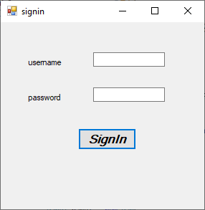

**\*\*\*\*\*\*\*\*\*\*\*\* Sign up form\*\*\*\*\*\*\*\*\*\*\*\***

using System;

using System.Collections.Generic;

using System.ComponentModel;

using System.Data;

using System.Drawing;

using System.Linq;

using System.Text;

using System.Threading.Tasks;

using System.Windows.Forms;

using ClassLibrary2;

namespace Assignment_1

{

public partial class Signup : Form

{

string a, b, c;

public Signup() { InitializeComponent(); }

private void button1_Click(object sender, EventArgs e)

{

Form1 A = new Form1(); this.Hide(); A.Show();

}

private void b1_Click(object sender, EventArgs e)

{

a = t1.Text; b = t2.Text; c = t3.Text;

if (b == c)

{

Form1.a1.iinsa(a.ToString(), b.ToString()); MessageBox.Show("SUCCESSFUL .", "Alert", MessageBoxButtons.OK, MessageBoxIcon.Information);

}

else { MessageBox.Show("INCORRECT PASSWord."); }

}

private void Signup_Load(object sender, EventArgs e)

{

}

}

}

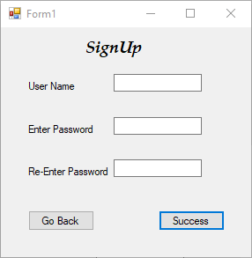

**\*\*\*\*\*\*\*\*\*\*\*\* dll code\*\*\*\*\*\*\*\*\*\*\*\***

namespace ClassLibrary2

{

public class Class1

{

string[,] u = new string[100, 2];

static public int count = 0;

public int counter() { return ++count; }

public void iinsa(string ac, string b)

{

int a = 0; while (u[a, 0] != null)

{ ++a; }

u[a, 0] = ac; u[a, 1] = passworddecode(b);

}

public bool v(string a, string b)

{

for (int i = 0; i <= 100; i++)

{

if (a == u[i, 0] && passworddecode(b) == u[i, 1]) { return true; }

}

return false;

}

public string passworddecode(string a)

{ return a.Length.ToString(); }

public int totalamount(int a, int b, int c, int d, int e, int f, int g, int h, bool i, bool j, bool k, bool l)

{

int t = 0;

if (i)

{

t += (a * e);

}

if (j)

{

t += (b * f);

}

if (k)

{

t += (c * g);

}

return t;

}

}

}

**Component Diagram:-**

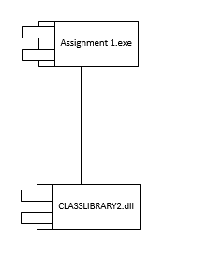

**Class diagram:**

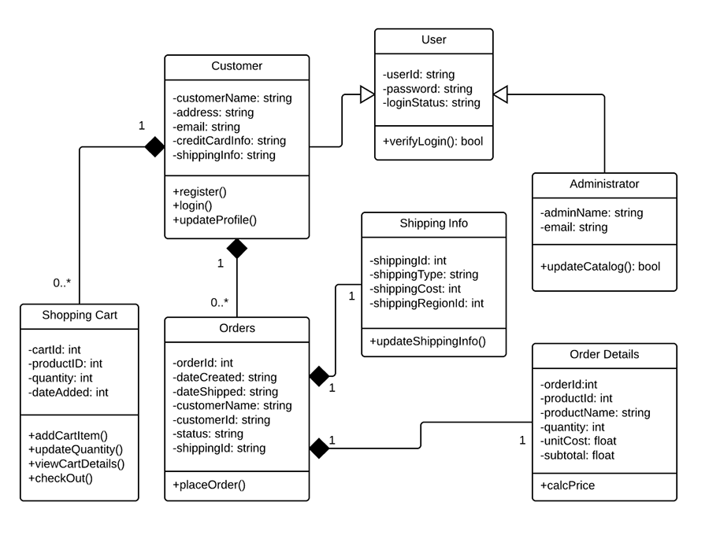

**Object diagram:**

